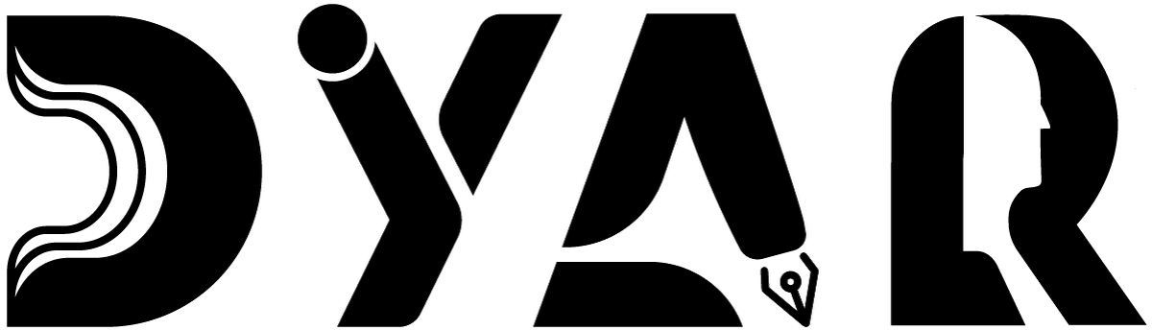
An NDIS Service Provider
RESOURCES HUB · DYAR STATEMENT
Conflict of Interest Statement
DYAR's transparency about decisions that affect you — full disclosure of COI-2026-001 to 004 in plain language.
Aligned to NDIS Practice Standards · NDIS Code of Conduct · NDIS Act 2013

Version 2 · 12 May 2026
DYAR Pty Ltd
NDIS Provider No. pending (Application 4-LRFP0J8) · ABN 68 695 255 504
Unit 1, 136 Main Street, Osborne Park WA 6017 · PO Box 8052, East Subiaco WA 6008
0470 540 306 · hello@dyar.com.au · Whadjuk Country

Conflict of Interest Statement & Service Delivery
DYAR's commitment to transparency about decisions that affect you
What is a conflict of interest?
A conflict of interest is when DYAR could benefit from a choice that may not be the best choice for YOU.
For example: DYAR might earn more if you use DYAR for ALL your supports — but the best choice for you might be to use DYAR for some + another provider for others.
DYAR's promise
DYAR will:
• ALWAYS tell you about conflicts of interest BEFORE you decide
• ALWAYS tell you the alternatives available
• NEVER pressure you to use DYAR for things we don't deliver well
• ALWAYS support you to choose what's best for you
DYAR's current conflicts of interest
COI-2026-001: Mutual Support Agreement with DYAR
DYAR's Director (Mehdi) also works at DYAR — another NDIS provider.
We have a written agreement that DYAR helps DYAR ONLY in an emergency (e.g., Mehdi unavailable).
What this means for you: in a true emergency, your supports may briefly come from DYAR workers — we will tell you immediately.
COI-2026-002: Sole-director arrangement
Mehdi is the only person currently delivering DYAR services.
This means one person is making decisions about your supports AND providing them.
What this means for you: an Independent Adviser is being appointed to review Mehdi's decisions quarterly. Your Lived Experience Advisory Group also reviews DYAR practice.
COI-2026-003: Founder Capital Contribution
Mehdi has personally loaned money to DYAR to get started.
DYAR will repay this loan over time.
What this means for you: NDIS money pays for your supports — not loan repayment. The loan is repaid from DYAR's profit (after wages + costs), not from your NDIS budget.
COI-2026-004: SDA + SIL same provider (for some participants)
Some participants live in DYAR's SDA AND get their SIL from DYAR too.
This means DYAR is both your landlord AND your support provider.
What this means for you: you have the right to change either at any time. An independent advocate reviews these arrangements annually.
Your rights when there's a conflict
• DYAR must TELL you about the conflict in plain language
• You can ASK for more information
• You can SAY NO to any DYAR-related option without losing supports
• You can ASK for an independent advocate
• You can COMPLAIN to the NDIS Commission (1800 035 544)
Where to find the full COI Register
DYAR's full COI Register is filed in our governance system (Centro Assist). Auditors and your advocate can review it on request.
Approved by: Mehdi Dabire — Director, DYAR Pty Ltd
Date: 19 May 2026
Next review: 19 August 2026 (quarterly)
___________________________________________
DYAR Pty Ltd · ABN 68 695 255 504 · Unit 1, 136 Main Street, Osborne Park WA 6017 · 0470 540 306 · hello@dyar.com.au · dyar.com.au · Whadjuk Country · V1 19 May 2026

